**Assignment 1 – Module 7**

**Problem 4:**

**For each consistency error in Figure 1, you should identify the consistency rule violated and suggest possible resolutions of the error. The ERD has generic names to help will concentrate on finding diagram errors rather than focusing on the meaning of the diagram,**

**Given ERD Diagram:**



**ERD Rule Violations:**

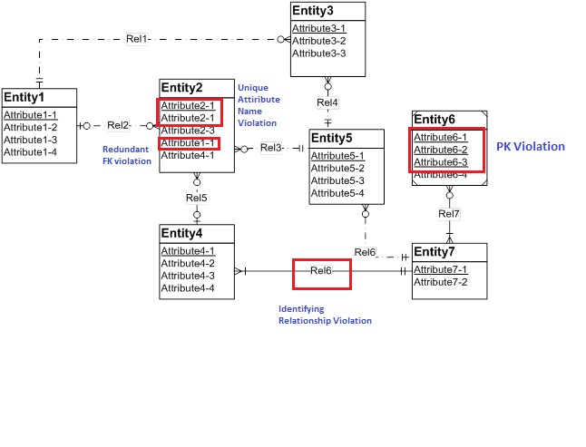

1. **Weak Entity ‘Entity 6’ is assigned with 3 primary keys.**
2. **‘Attribute 1-1’ in ‘Entity2’ is redundant foreign key.**
3. **Unique key violation for Attribute2-1 in Entity2**
4. **Identifying relationship violation for ‘Rel6’**